Mass-Mail Dispatcher

PROJECT REPORT

Submitted By

Abhishek Powar (College PRN : 2103036)

As Project Of Summer Internship by

Exposys Data Labs

Abstract

**In today’s digital age, emailing plays a critical role in communication. As part of daily operations, we often need to send emails to multiple recipients for efficiency and security. To address this, we've developed a unique mailing system that simplifies the process by allowing users to add recipients' email addresses (50-60 at a time) into a single CSV file for bulk mailing. This system also supports sending attachments, such as images or Word documents, to selected recipients listed in the CSV. If any email addresses contain errors (e.g., incorrect domain or symbol errors), they are flagged as "invalid" and stored in a separate file. The rest of the valid emails are processed and sent to the intended recipients. This solution, developed using web technologies such as PHP, PHP-Mailer, and Composer, not only enhances security but also saves time by allowing users to send bulk emails efficiently.**

**Introduction**:

**Every day, millions of emails are sent globally, and inevitably, some of these emails contain invalid addresses. However, in the process of Mass-Mailing through a CSV file, the occurrence of invalid emails is significantly reduced. The primary goal of Mass-Mailing is to send a large volume of emails simultaneously, rather than individually, to save time and improve efficiency. This approach is particularly valuable in today’s fast-paced environment, making it a highly efficient solution.**

# Objective of the System:

**The purpose of this project is to enable the sending of bulk emails efficiently, while minimizing the occurrence of invalid email addresses. This process not only saves time but also ensures that emails reach the intended recipients. The system can perform the following tasks:**

1. **Read CSV Files: It processes CSV files containing a large number of email addresses.**
2. **Attachment Support: The system allows for the sending of text, audio, and video files as attachments.**
3. **File Existence Check: It verifies whether the specified CSV file exists in the system’s file manager. If the file is missing, an error message is generated.**
4. **Valid Email Detection: It reads the CSV file, detects valid email addresses, and successfully sends emails to them.**
5. **Invalid Email Handling: Invalid email addresses are detected and stored in a separate CSV file for the user's convenience.**

## Use Cases:

# Send Mails Quickly: This system can send mail fast.

* + **Decrease In payload: Removing the invalid mails and stores into another CSV file which saves lot of time.**

# Usability: The PHP mailer library can be used by multiple users in order to send bulk mail with attachment.

**Users of the system:**

# Any personnel (tester, developer, etc.) can send the bulk mails through the CSV file and if there is any defective mails in the CSV file then these defective mails will automatically store into another CSV file.

**SOFTWARE REQUIREMENT SPECIFICATION**

Software Requirement Specification (SRS) is comprehensive description of the environment for a system under development. The SRS fully describes what the system will do and how it is expected to perform.

# Functional Requirements:

1. A CSV file is use to store bulk mails (including valid and invalid mails) that will send to recipients, which will main part of our project.

1. A PHP program which will read the CSV file and return a list of valid and invalid mails.
2. PHP mailer (Framework of PHP) is a method which is used in

our system to send bulk mails easily and the whole process will made very fast.

1. SMTP can login to our server by using the panel. It will navigate easily to all mail account. It will work with PHP mailer.
2. Composer makes an appropriate scripting command which can make the procedure faster.

# Non-Functional Requirements:

The system should the following Characteristics:

* + Usable: The project should be efficient and user-friendly.
  + Available: The project resource should always be available to the engineer so that he can put this system to any project and it will compatible with all project.
  + Secure: This system should protected against invalid mails.

# Hardware and software Requirement Specifications:

**Hardware Requirements:**

* + Processor: CPU 3.20 GHz.
  + RAM: Minimum 4 GB.
  + Storage: Minimum 500 GB.

# Software Requirements:

* + **Operating System:** Window 10 and higher.
  + **Programming Language:** JavaScript, HTML, and CSS.
  + **Documentation:** Microsoft office word (2007).
  + **PPT (Presentation):** Microsoft power point (2007).

# INTRODUCTION TO MASS-MAIL DISPATCHER

* + **What is Mass-Mail Dispatcher?**

Mass-Mail Dispatcher is a system is use to send a bundle of bulk mails to number of recipients at a time. Now days it is very popular to send mails to huge recipients quickly. Now days every company can add this system with their website.

# Features:-

* + **Most Functionality:** Easy way to send bulk mail to huge recipients.
  + **Send multi-media File**: As well as send bulk mails we can

also easily send multi-media file (Audio, video, word file etc.) with attachment.

# Fastest pace of innovation: Now a days this process is made a fastest process for sending bulk mails to huge recipients at a time.

**JavaScript** **:** JavaScript (JS) is a lightweight, interpreted, or just-in-time compiled programming language with first-class functions. While it is most well-known as the scripting language for Web pages, many non-browser environments also use it, such as Node.js, Apache CouchDB and Adobe Acrobat. JavaScript is a prototype-based, multi-paradigm, single-threaded, dynamic language, supporting object-oriented, imperative, and declarative (e.g. functional programming) styles. 

## Benefits of JavaScript:

* Simple − JavaScript is simple to comprehend and pick up. Both users and developers will find the structure to be straightforward. Additionally, it is very doable to implement, saving web developers a tonne of money when creating dynamic content.
* Speed − JavaScript is a "interpreted" language, it cuts down on the time needed for compilation in other programming languages like Java. Another client-side script is JavaScript, which accelerates programme execution by eliminating the wait time for server connections.
* No matter where JavaScript is hosted, it is always run in a client environment to reduce bandwidth usage and speed up execution.
* Interoperability − Because JavaScript seamlessly integrates with other programming languages, many developers favour using it to create a variety of applications. Any webpage or the script of another programming language can contain it.
* Server Load − Data validation can be done within the browser itself rather than being forwarded to the server because JavaScript is client-side. The entire website does not need to be reloaded in the event of any discrepancy. Only the chosen area of the page is updated by the browser.

# How It Works

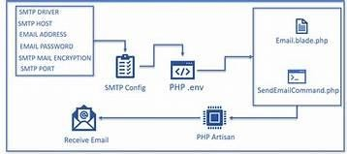

* **USE CASES:**
  + **SMTP authentication:** To test PHP mail functionality, we will use Mail trap, a fake SMTP server, so as not to flood our inboxes or even worse, the inboxes of our customers.
  + **Secure/MIME encryption:** Using PHP mailer we can send

mails securely.

* + **Support of TLS and SSL protocols:**TLS simply uses a hash- based message authentication code for authentication, while SSL combines application data, PHP mailer supports this protocol to send message.
  + **HTML content along with plain text:** PHPMailer provides

an option to read an HTML message body from an external file, convert referenced images to embedded as well as convert HTML into a basic plain-text alternative body.

* + **Multiple Documents with attachments:** By using PHP mailer we can send multiple documents with attachment.
* **Composer:** Composer allows us to declare the libraries in our PHP projects, automatically load the code of the libraries, create and add necessary files to the PHP project and update libraries when have a new version. Composer makes an appropriate scripting command which can make the procedure faster.

# Benefits of Composer:

* **Tracks Every version of Package:** Composer tracks which versions of packages you have installed in a file called composer. Lock, which is intended

to be committed to version control, so that when the project is cloned in the future, simply running composer install will download and install all the project's dependencies.

* **Deals with PHP Dependencies:** composer deals with PHP dependencies on a per-project basis. This makes it easy to have several projects on one machine that depend on separate versions of one PHP package.
* **Provide Autoloader:** Composer provides an autoloader, making it extremely easy to get started with any package.
* **Automatically provide Update Version:** Composer allows us to easily update a project to the latest version that is allowed by your composer.json.

# How it is Works:

The Composer is designed to send simple, quick messages that do not contain a lot of images or complex layouts. Very much like a standard email that you send to a co-worker or friend. You can do basic text formatting, insert images, links, and emojis. The composer is perfect for those times when you don’t need to send a more complex formatted message.

# Use Cases:

* **Provide Dependency Management:** Composer is a tool for dependency management in PHP. In simple words, Composer is used for managing libraries in your PHP project.
* **Declare Library:** Composer allows us to declare the libraries in your PHP projects, automatically load the code of the libraries, create and add

necessary files to the PHP projects, and update libraries when they have new versions.

* **Easily Search Package**: Packages is the primary repository for PHP Composer, and by default, the composer uses packagist.org to search for packages.
* **SMTP (Simple Mail Transfer Protocol):** SMTP represents Simple Mail Transfer Protocol. SMTP is a set of interaction guidelines that allow the software to transmit electronic mail over the internet, referred to as Simple Mail Transfer Protocol. The main objective of SMTP is used to set up communication rules between servers. The servers have a way of recognizing themselves and announcing what kind of communication they are trying to perform. They also have a way of handling errors such as incorrect email address. SMTP can login to our server by using the panel. It will navigate easily to all mail account. It will work with PHP mailer.



# Benefits Of SMTP:

* **Simplicity:** SMTP provides the simplest form of communicating through email messages between various computers in a particular network. Here are no hassles for the end-users as they only need to type their email and send it to the recipient’s email address. The email will just go through a simple

process from the SMTP server to an exchange server for the recipient’s computer making the electronic communication simple and not complicated.

* + **Quick Mail Delivery:** Since SMTP is developed from a simple platform, email messages may be sent easily and quickly.
  + **Reliability:** SMTP also offers reliability in terms of outgoing email messages. If there are instances where a particular message was not successfully sent, the SMTP server will always try to re-send the same email until the transmission becomes successful.
* **Option for dedicated servers:** With SMTP, companies and organization s may option to have a dedicated server to handle outgoing email messages. Although web mail services and ISPs may offer the same services, not many of them can actually provide exclusivity when it comes to mail servers. This could mean problems with email transmission. ‘Â But with SMTP, servers are maintained locally and may be configured to exclusively handle very important and sensitive email messages.

# How it Works:

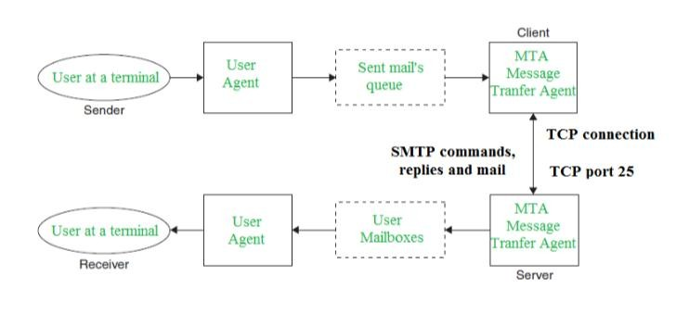

* **Use Cases:**
* **Communication Between Sender & Receiver:** The sender’s user agent prepares the message and sends it to the MTA. The MTA’s responsibility is to transfer the mail across the network to the receiver’s MTA. To send mails, a system must have a client MTA, and to receive mails, a system must have a server MTA.
* **Sending Mail:** Mail is sent by a series of request and response messages between the client and the server. The message which is sent across consists of a header and a body.
* **Receiving Mail:** The user agent at the server-side checks the mailboxes at a particular time of intervals. If any information is received, it informs the user about the mail. When the user tries to read the mail it displays a list of emails with a short description of each mail in the mailbox. By selecting any of the mail users can view its contents on the terminal.
* **Mail Delivery:** The domain name and username of the receiver are the two parts of an email address. Let's assume, for instance, [abcd@gmail.com,](mailto:abcd@gmail.com) in which "abed" is the username, and "gmail.com" is the domain. If the recipient's e-mail address does not coordinate with the sender's domain name, then the mail submission s agent (MSA) will transfer the mail (MTA).
* **Receipt & Processing:** After getting the incoming message, the exchange server passes it to the Mail Delivery Agent. It collects the e-mail and sets it for retrieval by the user.

# Overview Of the System

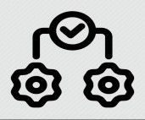

**Mail**

**Check Valid?**

**Not**

**Sent**

**Check SMTP**

**Configuration**

**Yes**

**Mail send**

**Mail send to Receiver**

**Input Library**

**Sender ** 





**CSV File Attachment file**

**SMTP Port**

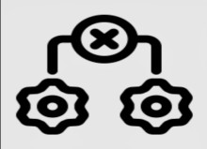

**No**

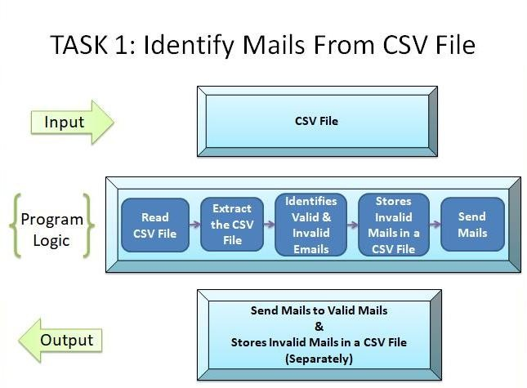

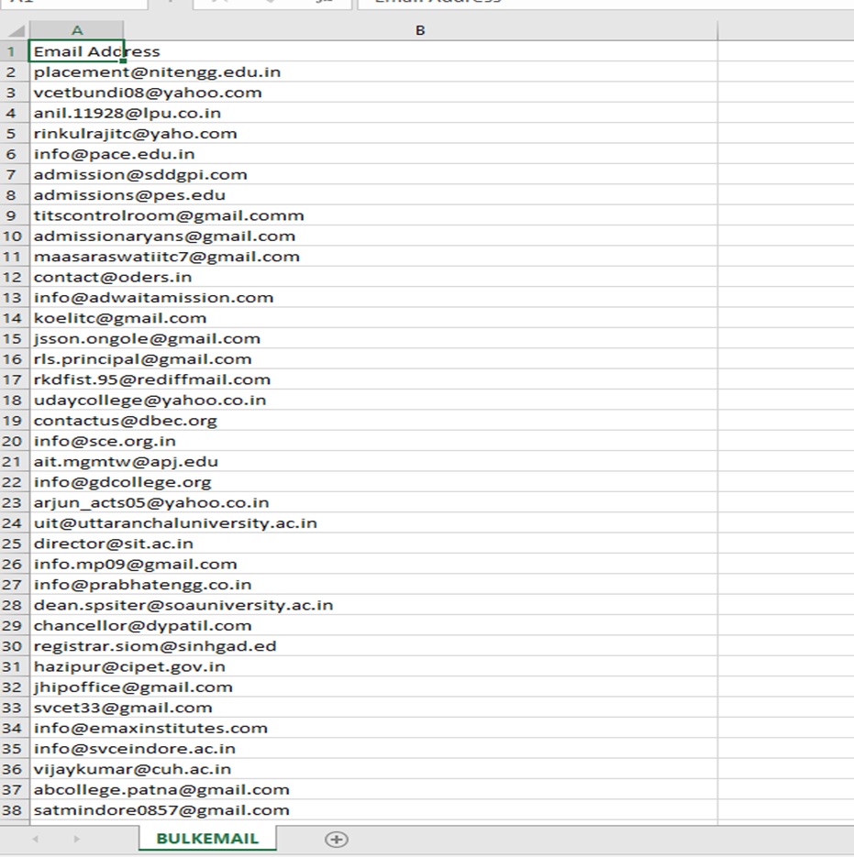

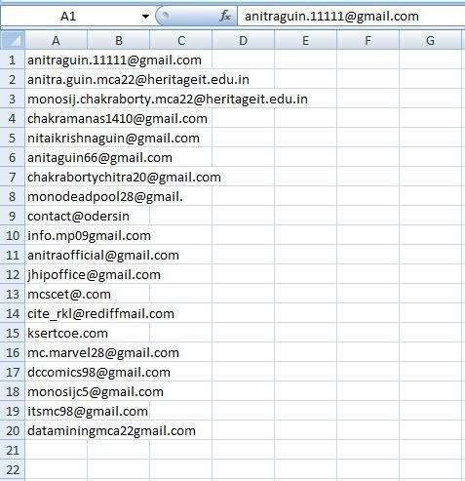

Input .CSV file

**Note:**

This CSV File Contains a mixture Of Valid & Invalid Mails. Our system takes this as input. Here we took an Example of 20 mails, but in real we can Deal with thousand of mails.

# Task 2: Detect Invalid Mail

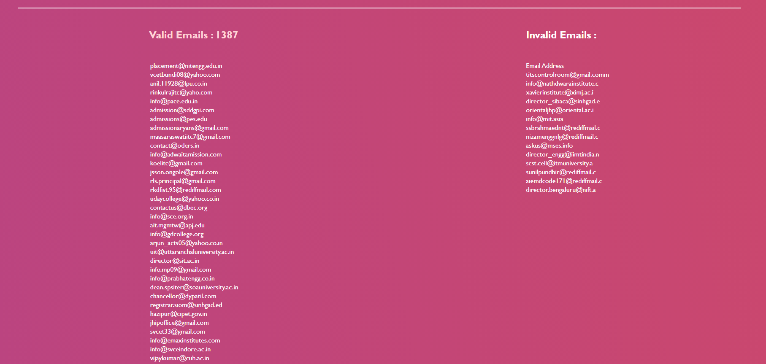

# Tools Used:



**VS-Code (Visual Studio Code) For Web-Developers-**

**Visual Studio Code is “a free-editor that helps the programmer write code helps in debugging and corrects the code using the intelli-sense method”. In normall terms, it facilitates users to write the code in an easy manner. Many people say that it is half of an IDE and an editor, but the decision is up to to the coders. Any program/software that we see or use works on the code that runs in the background. Traditionally coding was used to do in the traditional editors or even in the basic editors like notepad! These editors used to provide basic support to the coders.**

**JavaScript**



**JavaScript (JS) is a lightweight, interpreted, or just-in-time compiled programming language with first-class functions. While it is most well-known as the scripting language for Web pages, many non-browser environments also use it, such as Node.js, Apache CouchDB and Adobe Acrobat. JavaScript is a prototype-based, multi-paradigm, single-threaded, dynamic language, supporting object-oriented, imperative, and declarative (e.g. functional programming) styles.**



**HTML (Hypertext Markup Language)-** HTML is an acronym which stands for Hyper Text Markup Language which is used for creating web pages and web applications. HTML is a markup language which is used for creating attractive web pages with the help of styling, and which looks in a nice format on a web browser. An HTML document is made of many HTML tags and each HTML tag contains different content.



**CSS(Cascading Style Sheet):** Cascading Style Sheets, fondly referred to as CSS, is a simple design language intended to simplify the process of making web pages presentable. CSS handles the look and feel part of a web page. Using CSS, you can control the color of the text, the style of fonts, the spacing between paragraphs, how columns are sized and laid out, what background images or colors are used, layout designs, and variations in display for different devices and screen sizes as well as a variety of other effects.